 | 26.15 Editors - Properties Editor - Material Properties Tab
Table of content
Detailed table of content 1
Preface 6
Material header 6
Preview Panel 10
Surface Panel 11
Surface Panel - Grease Pencil Object 12
Volume Panel 17
Displacement Panel 17
Settings Panel - Eevee renderer 18
Settings Panel - Cycles renderer 19
Line Art 20
Viewport Display 21
Custom Properties panel 23

Detailed table of content

Detailed table of content
Detailed table of content 1
Preface 6
Affected Renderer 6
Material header 6
Material List 7
Show in ghosts 7
Hide 7
Locked 7
Drag Handler 7
Search Field 7
Sort by Name 7
Reverse 7
Add Material Slot 7
Remove Material Slot 7
Materials Specials menu 8
With a mesh or curve or other object type 8
Copy Material 8
Copy Material to selected 8
Paste Material 8
Remove Unused Slots 8
With a grease pencil stroke object 8
Show All 8
Hide Others 8
Lock All 8
Unlock All 8
Lock Unused 8
Remove Unused Slots 8
Merge Similar 8
Convert Materials to Vertex Colors 8
Extract Palette from Vertex Color 9
Append Active Layer to Object 9
Append all Layers to Object 9
Material data property 9
Material Browser 9
New 9
Name 9
Fake User 9
New 9
Remove 9
Link 9
Right Click menus 9
Edit Mode 10
Workflow 10
Assign 10
Select 10
Deselect 10
Preview Panel 10
Flat, Sphere, Cube, etc. 10
Preview World 10
Surface Panel 11
Use Nodes 11
Use Nodes unticked with Eevee 11
Use Nodes unticked with Cycles 11
Use Nodes ticked 11
Surface Panel - Grease Pencil Object 12
Presets 12
Stroke Subpanel 12
Mode Type 12
Mode Type Line 12
Style 12
Solid 12
Base Color 12
Texture 12
Base Color 12
Image Prop 12
Image browser 13
Search form 13
Image Edit Box 13
Number of Fake Users 13
Fake User 13
Open 13
Remove 13
Self Overlap 13
Holdout 13
Mode Type Dots + Squares 13
Style 13
Solid 13
Base Color 13
Texture 14
Base Color 14
Image Prop 14
Image browser 14
Search form 14
Image Edit Box 14
Number of Fake Users 14
Fake User 14
Open 14
Remove 14
Alignment 14
Path 14
Object 14
Fixed 14
Self Overlap 15
Rotation 15
Holdout 15
Fill Subpanel 15
Style 15
Solid 15
Base Color 15
Holdout 15
Gradient 15
Gradient Type 15
Base Color 15
Secondary Color 15
Blend 15
Flip Colors 15
Location X / Y 15
Rotation 16
Scale X / Y 16
Holdout 16
Texture 16
Base Color 16
Image Prop 16
Image browser 16
Search form 16
Image Edit Box 16
Number of Fake Users 16
Fake User 16
Open 17
Remove 17
Location X / Y 17
Rotation 17
Scale X / Y 17
Clip Image 17
Holdout 17
Volume Panel 17
Use Nodes 17
Displacement Panel 17
Use Nodes 17
Settings Panel - Eevee renderer 18
Pass Index 18
Surface subpanel 18
Backface Culling 18
Camera 18
Shadow 18
Max displacement 18
Transparent Shadows 18
Render method 18
Dithered 18
Raytraced refraction 18
Blended 19
Transparency Overlap 19
Light Probe Volume 19
Single Sided 19
Volume subpanel 19
Intersection 19
Fast 19
Accurate 19
Settings Panel - Cycles renderer 19
Pass Index 19
Surface 19
Multiple Importance 19
Transparent Shadows 19
Displacement 20
Volume 20
Sampling 20
Interpolation 20
Homogeneous 20
Step rate 20
Line Art 20
Material Mask 20
Levels 20
Intersection Priority 20
Intersection Priority Value 20
Viewport Display 21
Settings 21
Backface Culling 21
Blend Mode 21
Opaque 21
Alpha Clip 21
Clip threshold 21
Alpha Hashed 21
Alpha Blend 22
Shadow Mode 22
None 22
Opaque 22
Alpha Clip 22
Clip threshold 22
Alpha Hashed 22
Show Backface 22
Screen Space Refraction 22
Refraction depth 22
Subsurface Translucency 22
Pass Index 22
Custom Properties panel 23
Add 23
Property Value 23
Edit 23
Remove 23

Preface
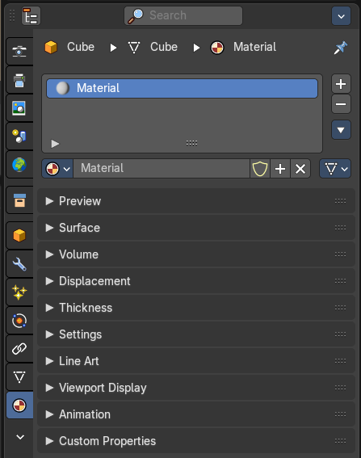
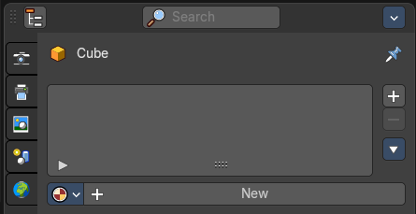
Materials controls the appearance of meshes, curves, volumes and other objects.

A material is the container that contains all the necessary data to define the look of an object. I is made of a code part, the shaders. They control how the surface reacts. And color data like textures. A black and white texture can also control what areas of a shader reacts in what way. Like a gloss map.

Materials can be created in either the Material properties, or in the Shader Editor. The content that is displayed is the same. But the way how it is represented is different.

Materials can be assigned to one or more objects, and different materials can be assigned to different parts of meshes.

The material system is built with physically-based rendering in mind. But can also be used to create toon style materials.

Affected Renderer
The material system is for Eeevee and Cycles. Workbench renderer is meant for fast preview display. It does not use materials like Eevee or Cycles. All you can choose is a color.
Eevee and Cycles have nearly the same nodes available. But some nodes differs. Eevee is a realtime renderer. Cycles is a physically based render. That's two different approaches. So you should take that into account when creating the materials.

Material header

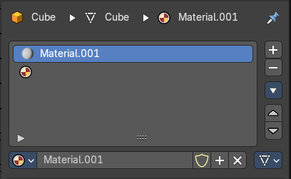
The header area contains the list of materials and the functionality to create new materials and to remove them.

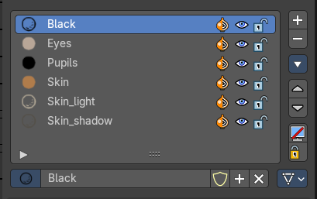
Note that a material for a grease pencil object differs from the rest. It is basically the same. But grease pencil objects have other icons in the material browser.

Material List
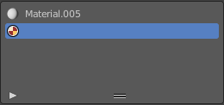
The list of assigned materials to this object. The list shows the material slots. A material slot that has the red material icon assigned has no material content yet. It is just an empty slot. You have to create it first by clicking at the New button below, in the material property.
Clicking at the name allows renaming of the material.
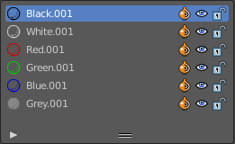
Grease pencil materials have additional functionality in the list.

Show in ghosts
Turn on onion skinning for this material. Onion skinning displays strokes before and after the current frame.

Hide
Show or hide the material.

Locked
Protect color from further editing.

Drag Handler
The two vertical lines at the end is a handler with which you can expand the list.

Search Field

You can expand a search field at the bottom of the list. Type in your term and hit enter to filter for your term.

Sort by Name
Sort the List by name.

Reverse
Exclude the search term instead of searching for it.

Add Material Slot
Add a new material slot

Remove Material Slot
Remove the selected material slot.

Materials Specials menu

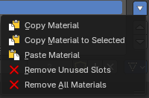
With a mesh or curve or other object type

Copy Material
Copy the material settings and nodes.

Copy Material to selected
Copy material to selected objects. First select the object without material. Hold down shift and select the object with material. Perform Copy material to selected.

Paste Material
Pastes a copied material.

Remove Unused Slots
Remove material slots that does not contain a material.

Remove All Materials
Removes all material slots

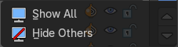
With a grease pencil stroke object

Show All
Show all materials.

Hide Others
Hide unselected materials.

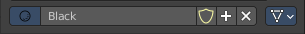
Material data property

Material Browser
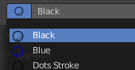
A list of the available materials in the scene where you can choose a material from.

New
When the object has no material yet. Creates a new default material and adds a first material slot to the list.

Name
The name of the active material. Double clicking allows to rename it.

Fake User
Keep this data even when it has no user in the scene.

New
Creates a new default material, and assigns it to the active material slot.

Remove

Link
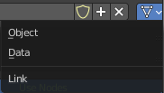
Specifies whether the material is to be linked to the Object or to the Object Data.
Different objects may share the same mesh data. And if the material is linked to the mesh, every object will share it. If the material is linked directly to the object data, the objects can have different materials and still share the same mesh. Default is Data.

Right Click menus
When you right click at the material property then you will reveal context menus with different content, dependant of where you click. Most of the content is explained in chapter 6, the general right click menu functionality. The rest should be self explaining.

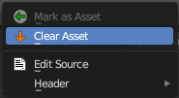
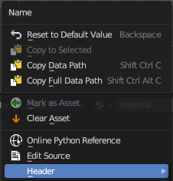
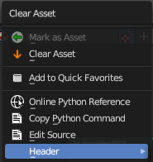
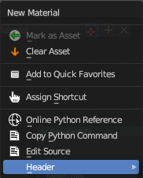

Edit Mode
In Edit mode you can assign different materials at different mesh or curve parts.

Workflow
Enter Edit Mode. Select the material that you want to assign. Select the mesh or curve part. Click at the assign button.

hier weiter

Assign
Assign active material slot and material to the selected faces in the mesh, strokes in a Grease Pencil, and similar for other object types.

Select
Select faces assigned to the active material slot.

Deselect
Deselect faces assigned to the active material slot.

Preview Panel

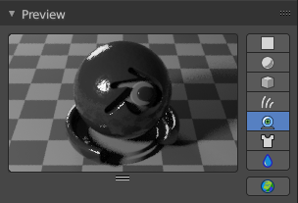
A preview window to judge the material.

Flat, Sphere, Cube, etc.
Different shaped preview objects.

Preview World
Include the world settings into the preview rendering.

Surface Panel

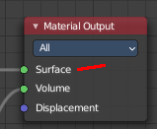
This panel displays the Surface part of the material as a list. And allows you to edit its values.

Use Nodes
Choose if you want to use nodes or not. Unticked it will use a default material with just basic values. Ticked it will use the material as defined in the shader editor in the Shading workspace. And display its values.
The values with unticked Use Nodes will not appear in the material node editor.

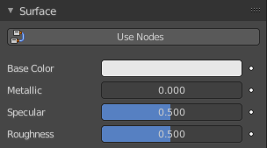
Use Nodes unticked with Eevee
Gives you the values for a very basic PBR realtime shader.

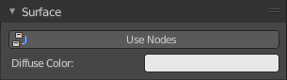
Use Nodes unticked with Cycles
Gives you a base color.

Use Nodes ticked
Displays the content of the material in the shader editor as a list.
Triangle buttons indicates that there is a node connected to this input. You can expand this triangle to access the values of the connected node.
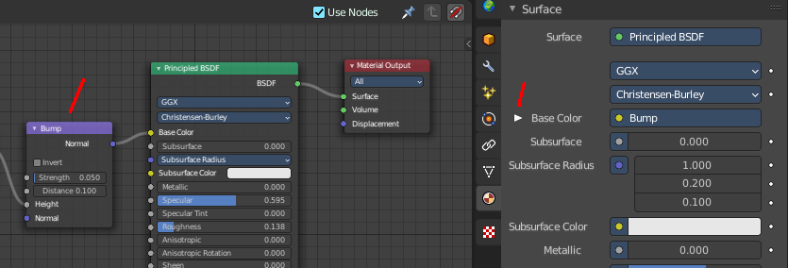

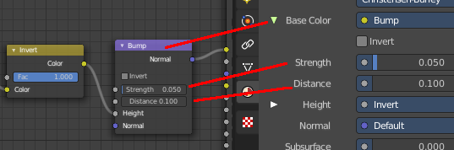

For the nodes and the values please have a look in the shader editor.

Surface Panel - Grease Pencil Object
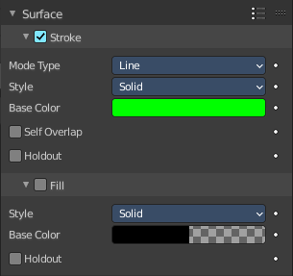
The content of the surface panel with a grease pencil object is a bit different from other object types since Grease pencil objects uses materials for the drawing color.

Presets
The presets in the header allows you to use and store presets.

Stroke Subpanel
Stroke related settings.

Mode Type
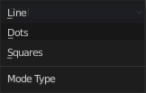
The draw mode for the stroke. The modes should be self explaining. Most settings are the same in all modes.

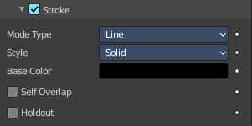
Mode Type Line

Style
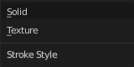
The draw style.

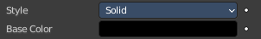
Solid

Base Color
The color of the stroke.

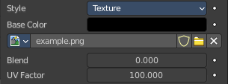
Texture

Base Color
The base color of the stroke. You can blend the texture with this color.

Image Prop
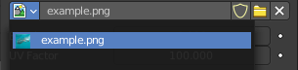
This property contains the list of loaded images. When no image is loaded then it displays the Open Buttons. When an image exists then it displays the name of the currently selected image.

From left to right ...

Image browser
This is a list of the images in the scene. This list allows you to switch to other images.

Search form
Search for specific images.

Image Edit Box
Read the name of the currently selected image. And you can rename the image here too.

Number of Fake Users
In case this file has a fake user assigned, then this number displays the number of fake users.

Fake User
Wit this button you assign a fake user to this selected image.
Data, like images, that is not longer linked to anything else gets removed when you save and reload a scene. Bforartists has the concept of fake users to go around this behavior. An image with a fake user is in fact linked to something. And so it is not lost when you save and reload the scene.

Open
Open a new image.

Remove
Removes the image.

Self Overlap
Disable stencil and allow self intersections with alpha materials.

Holdout
Remove the color from underneath this stroke by using the stroke as a mask.

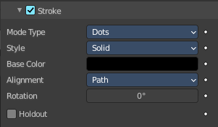
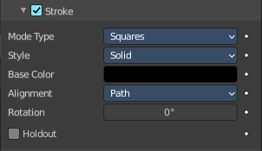
Mode Type Dots + Squares

Style
The draw style.

Solid

Base Color
The color of the stroke.

Texture

Base Color
The base color of the stroke. You can blend the texture with this color.

Image Prop
This property contains the list of loaded images. When no image is loaded then it displays the Open Buttons. When an image exists then it displays the name of the currently selected image.

From left to right ...

Image browser
This is a list of the images in the scene. This list allows you to switch to other images.

Search form
Search for specific images.

Image Edit Box
Read the name of the currently selected image. And you can rename the image here too.

Number of Fake Users
In case this file has a fake user assigned, then this number displays the number of fake users.

Fake User
Wit this button you assign a fake user to this selected image.
Data, like images, that is not longer linked to anything else gets removed when you save and reload a scene. Bforartists has the concept of fake users to go around this behavior. An image with a fake user is in fact linked to something. And so it is not lost when you save and reload the scene.

Open
Open a new image.

Remove
Removes the image.

Alignment
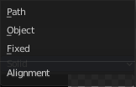
Dots and Squares mode.

Path
Alignment follows stroke drawing path and object rotation.

Object
Alignment follows object rotation only.

Fixed
Keeps aligned with viewport.

Self Overlap
Disable stencil and allow self intersections with alpha materials.

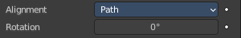
Rotation
Additional rotation applied to dot and square strokes.

Holdout
Remove the color from underneath this stroke by using the stroke as a mask.

Fill Subpanel
Fill color related settings.

Style

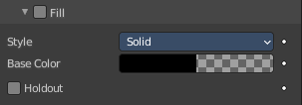
Solid

Base Color
The color of the stroke.

Holdout
Remove the color from underneath this stroke by using the stroke as a mask.

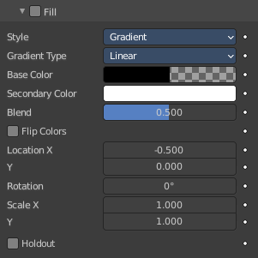
Gradient

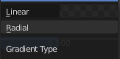
Gradient Type
Draw a linear or a radial gradient.

Base Color
The first color of the gradient.

Secondary Color
The second color of the gradient.

Blend
The mix factor between the first and second gradient color.

Flip Colors
Flip the filling colors.

Location X / Y
The location of the gradient.

Rotation
The rotation of the gradient.

Scale X / Y
The scale of the gradient.

Holdout
Remove the color from underneath this stroke by using the stroke as a mask.

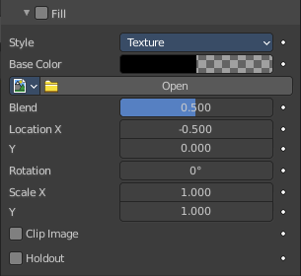
Texture

Base Color
The base color of the stroke. You can blend the texture with this color.

Image Prop
This property contains the list of loaded images. When no image is loaded then it displays the Open Buttons. When an image exists then it displays the name of the currently selected image.

From left to right ...

Image browser
This is a list of the images in the scene. This list allows you to switch to other images.

Search form
Search for specific images.

Image Edit Box
Read the name of the currently selected image. And you can rename the image here too.

Number of Fake Users
In case this file has a fake user assigned, then this number displays the number of fake users.

Fake User
Wit this button you assign a fake user to this selected image.
Data, like images, that is not longer linked to anything else gets removed when you save and reload a scene. Bforartists has the concept of fake users to go around this behavior. An image with a fake user is in fact linked to something. And so it is not lost when you save and reload the scene.

Open
Open a new image.

Remove
Removes the image.

Location X / Y
The location of the image.

Rotation
The rotation of the image.

Scale X / Y
The scale of the image.

Clip Image
Do not repeat the image, but clamp it to one instance.

Holdout
Remove the color from underneath this stroke by using the stroke as a mask.

Volume Panel

This panel displays the Volume part of the material as a list. And allows you to edit its values.

Use Nodes
Choose if you want to use a volume node or not.
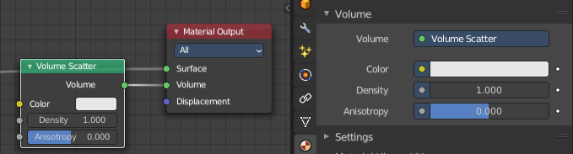

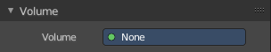
Removing the volume node in the shader editor will clear the volume panel.

Displacement Panel

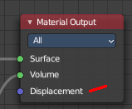
This panel displays the Displacement part of the material as a list. And allows you to edit its values.

Use Nodes
Choose if you want to use a displacement node or not.
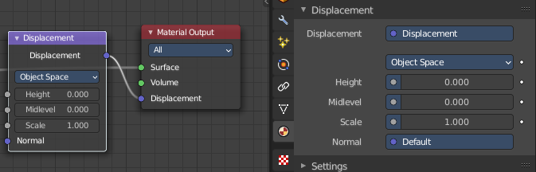

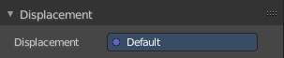
Removing the displacement node in the shader editor will clear the panel.

Settings Panel - Eevee renderer
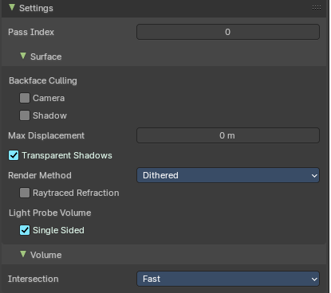

Pass Index
Index number for the material index pass.

Surface subpanel

Backface Culling

Camera
Use back face culling to hide the back side of faces.

Shadow
Use back face culling when casting shadows.

Max displacement
The maximum distance that a vertex can be displaced. Displacement over this threshold may cause visibility issues.

Transparent Shadows
Use transparent shadows for this material.

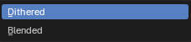
Render method

Dithered
Allows for grayscale hashed transparency, and is compatible with render passes and raytracing. This is also known als deferred rendering.

Raytraced refraction
Use raytracing to determine refracted color instead of using only light probes. This prevents the surface from contributing to the lighting of surfaces not using this setting.

Blended
Allows for colored transparency, but is incompatible with render passes and raytracing. This is also known als forward rendering.

Transparency Overlap
Render multiple transparent layers. Note that this may introduce transparency sorting problems.

Light Probe Volume

Single Sided
Consider materials single sided for light probe volume capture.

Volume subpanel

Intersection

Fast
Each face is considered as a medium interface. It gives correct results for manifold geometry that contains no inner parts.

Accurate
Faces are considered as a medium interface only when they have different consectuive facing. It gives correct results as longa s the max ray depth is not exceeded. This method also has a significant higher memory requirement.

Settings Panel - Cycles renderer

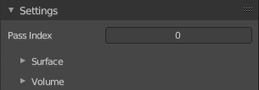
Material settings.

Pass Index
The index number of this material. This material index can be used for masking in post processing for example.

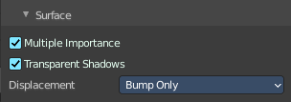
Surface
Surface related settings.

Multiple Importance
By default lights use only direct light sampling. Which can be noisy with sharp glossy reflections. Multiple Importance activates Indirect light sampling to reduce noise.

Transparent Shadows
Use transparent shadows if the material contains a transparent bsdf node.

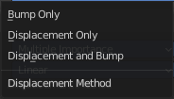
Displacement
What method to use for displacement.

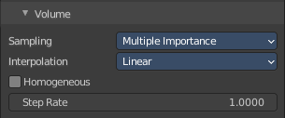
Volume

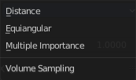
Sampling
What sampling method to use for volume rendering.

Interpolation
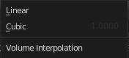
What interpolation method to use for volume rendering.

Homogeneous
Assume to have a homogeneous volume to speed up rendering.

Step rate
Scale the distance between volume shader samples when rendering the volume. Lower values increases accuracy and render time.
Step rate becomes dysfunctional when Homogeneous is activated.

Line Art

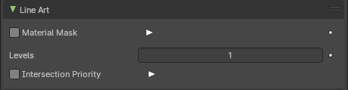
Material Mask
Use material masks to filter out occluded strokes. You can filter out up to eight mask bits. The index starts with 0.

Levels
Faces with this material will behave as if it has set nubmers of layers in occlusion.

Intersection Priority
Overwrite object and collection priority value.

Intersection Priority Value
The intersection line will be included into the object with the higher intersection priority value.

Viewport Display

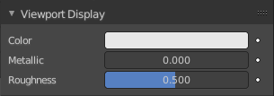
Display settings for viewport display mode Solid. The items should be self explaining.
In solid mode the material colors are not displayed. With the viewport display color you can change this, and give each material its own color. Which can be any color, not necessarily the color from the material. Each material can have its own viewport display color.
Note that the Workbench renderer does not use materials and its colors at all. It relies completely at the viewport display color, even for rendering. But you can also here use different materials to have different colors at the mesh.

Settings
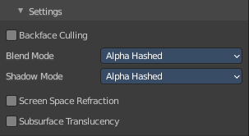
Cycles only. And with Cycles these settings are just relevant for the viewport rendering in Material Preview mode. That's why they are in the viewport display panel.
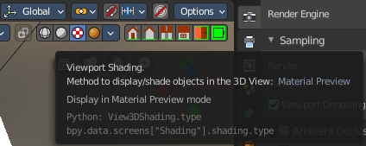

Backface Culling
Use back face culling to hide the back side of faces.

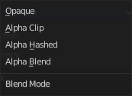
Blend Mode
The blend mode for transparent faces.

Opaque
Render surface without transparency.

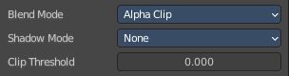
Alpha Clip
Use the alpha threshold to clip the visibility. On or off.

Clip threshold
A pixel is just rendered if the value is higher than this clip threshold. This threshold is the same for blend mode and shadow mode.

Alpha Hashed
Use Noise to dither the binary visibility. Works best with multi samples.

Alpha Blend
Render polygons transparent, dependent of the alpha channel of the texture.

Shadow Mode

None
Material will cast no shadow.

Opaque
Material will cast shadow without transparency.

Alpha Clip
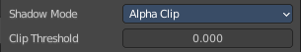
Use the alpha threshold to clip the visibility. On or off.

Clip threshold
A pixel is just rendered if the value is higher than this clip threshold. This threshold is the same for blend mode and shadow mode.

Alpha Hashed
Use Noise to dither the binary visibility.

Show Backface
With Blend Mode Alpha Blend. Limit the transparency to a single layer to avoid transparency layer sort problems.

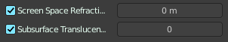
Screen Space Refraction
Use ray traced screen space refraction.

Refraction depth
The thickness of the object to compute two refraction event. 0 means disabled.

Subsurface Translucency
Add translucency effect to subsurface.

Pass Index
Index number for the material index render pass.

Custom Properties panel
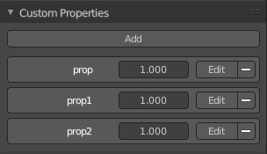
This panel exists for all object types in the Object Data Properties. Allows you to add custom properties that can be used in various ways then. For scripting, or to drive animation etc.
In this panel you might also find custom properties from addons or scripts.

Add
Adds a new property.

Property Value
The value of the property.

Edit
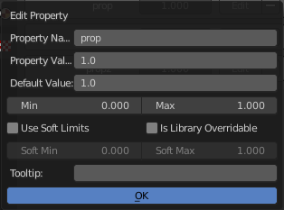
Opens a panel where you can adjust the settings for the custom property. The settings should be self explaining.

Remove
Removes the property.

